Old Inn Drinks List Mulled Wine Now Being Served!
Alc % | Draught Ale | Pint | Half Pint
4.4 | Dartmoor – Dragons Breath | 5 | 2.60
4.7 | Badger’s Tanglefoot | 5.20 | 2.70
 | Draught Lager / IPA
4.8 | Cruzcampo | 6.25 | 3.20
4.2  5 | Forum (Helles)  West Coast IPA | 5.40  5.60 | 2.70  2.90
 | Draught Cider / Stout
4.8 | Thatchers Gold | 5.20 | 2.60
4.8  4.0  4.1 | Thatchers Haze  ***Warm Mulled Cider***  Guinness | 5.20  6  6 | 2.60  3  3
 | Bottled Beer/Cider | Vol | £
4.5  5.1 | Sol  Peroni | 330ml  330ml | 4.50  4.50
5 | Twice Tangled IPA | 500ml | 5
 | Badger Ales | 568ml | 5
4 | Crabbies Ginger | 568ml | 5
4  4 | Olde Mout Fruit Ciders  Thatchers Rose | 500ml  500ml | 5.50  5
4.2  4.2  5.2  5 | Outland Cans  Hazy IPA  Peach Lager  Milk Stout  Ginger Pale Ale  Zero % | 540ml  540ml  540ml  540ml | 5.50  5.50  5.50  5.50
0.0  0.5 | Peroni Libera  Pine Trails Pale Ale | 330ml  330ml | 4  4
0.5 | Big Drop IPA | 330ml | 4
0.0  0.0  0.5 | Olde Mout - Berries  Thatchers – Apple  Guinness | 500ml  500ml  440ml | 4.50  4.50  4.50

Alc % | Spirits - 25ml | £
37.5 | Smirnoff Red | 3.60
40 | Grey Goose | 4.50
38 | Tequila Reposado | 4
38 | Luxado Sambuca | 4
0.0 | Our Gin Selection - 25ml  Salcombe Nll – 0% - 3 flavours | 3.60
37.5 | Gordon’s | 3.60
40 | Dartmoor 1890 | 4.80
41.4  40 | Hendricks  Dorset Conker | 4.80  4.80
43 | Whitley Neil | 4.60
41.6 | Sipsmith | 4.80
43.1 | Tanqueray | 4.20
43 | Silent Pool | 4.60
40 | Slingsby - Marmalade | 4.60
48  48 | Blushing Monkey - Pink  Dancing Dragon Tail | 5.20  5.20
26 | Gordon’s Sloe Gin | 3.60
40 | Rum  Captain Morgan Dark | 3.60
35 | Captain Morgan Spiced | 3.60
40 | Mount Gay | 4
40 | Sailor Jerry | 4
40 | Kraken Spiced Rum | 4
21 | Malibu | 3.60
37.5 | Bacardi Carte Blanca | 3.60
 | Liqueurs / Fortified Wines
28 | Archers 25 ml | 3.60
18 | Amaretto 25 ml | 3.80
15 | Martini 50ml | 4.50
17.5 | Bristol Cream 50 ml | 4.50
17.5 | Croft Dry Sherry 50ml | 4.50
15 | Baileys 50 ml | 4.80
20 | Tia Maria 25 ml | 4
13.5 | Stones Ginger Wine 50ml | 3.20
40 | Cointreau 25ml | 4
25 | Campari 25ml | 3.80
25 | Pimm’s No1 50ml | 4.50
35 | Southern Comfort | 4.20
19 | House Port 50ml | 4.50
40 | Drambuie 25ml | 4

Soft Drinks |  |  |  | Vol |  |  |  |  |  | £
Schweppes….  Tonic, Slimline Tonic, Ginger Ale or Bitter Lemon |  |  |  | 200ml  200ml |  | 2.60 |  |  |  | 2.50  2.50
Fentimans Tonic Water…  Elderflower or Rhubarb |  |  |  | 200ml |  | 3 |  |  |  | 2.90
Frobisher Cranberry |  |  |  | 250ml |  | 3.60 |  |  |  | 3.40
Cracker Fruit Juice…  Apple or Orange |  |  |  | Half/Pint |  | 2.80/5 |  |  |  | 2.50/4.50
Hildon Mineral Water…  Still or Sparkling |  |  |  | 200/750ml |  | 2.80/5.50 |  |  |  | 2.60/5
Luscombe…Ask for Flavours |  |  |  | 275ml |  | 3.60 |  |  |  | 3.40
J2O…Ask for Flavours |  |  |  | 275ml |  | 3.50 |  |  |  | 3.30
Appletiser |  |  |  | 250ml |  | 3.50 |  |  |  | 3.30
Cordial |  |  |  | 12oz/22oz |  | 1.60/2.20 |  |  |  | 1.40/2
Soda Water |  |  |  | 120z/22oz |  | 1.20/1.80 |  |  |  | 1/1.60
Schweppes Lemonade |  |  |  | 12oz/22oz |  | 3.20/3.80 |  |  |  | 3/3.60
Coca Cola/Diet Coke |  |  |  | 12oz/oz |  | 3.20/3.80 |  |  |  | 3/3.60
Coca Cola Bottle |  |  |  | 330ml |  | 3.60 |  |  |  | 3.60
Diet Coke / Zero |  |  |  | 330ml |  | 3.40 |  |  |  | 3.40
Cawston Juice Carton  Fruit Shoot |  |  |  | 200ml  200ml |  | 2.50  2.50 |  |  |  | 2.50  2.50

Alc % | Whiskey / Brandy | £
40 | Famous Grouse 25ml | 3.60
40 | Jamesons 25ml | 4.20
40 | Jack Daniels 25ml | 4.20
45.8 | Talisker 10yo 25ml | 4.80
40 | Laphroaig 10 25ml | 5.20
43 | Oban 14 25ml | 5.80
40 | Glenfiddich 12 25ml | 4.80
40 | Courvoisier VS 25ml | 4.40
40 | Remy Martin VSOP 25ml | 5.40
 | Dartmoor Whisky
46 | Bourbon Cask | 5
46 | Bordeaux Cask | 5
46 | Sherry Cask | 7.50

OLD INN
Wine List
White
Listening Station, Chardonnay –13% Australia Refreshing unoaked, citrus and white peach flavours combine with zesty fresh acidity and a clean, bright and linear finish.
175ml £6 | 250ml £7.80 | Bottle £23
Conviviale, Pinot Grigio – 12.5% Italy Fresh and delicately dry, its ripe peach and citrus fruit flavours are balanced by crisp acidity and hints of honey and nuts.
175ml £6 | 250ml £7.80 | Bottle £23
Ribbonwood, Sauvignon Blanc, Marlborough –13% NZ Aromas of grapefruit peel and a hint of thyme. On the palate, there are flavours of bitter lemon with sweet herbal and redcurrant flavours.
175ml £8.55 | 250ml £9.95 | Bottle £29
Rag and Bone – Riesling, Edan Valley -10.5% Australia Dry, bright and zingy, well rounded, succulently juicy.
Bottle £35
Rosé
Pasquiers, Grenache & Cinsault – 11% France Pale Salmon pink with hints of summer meadow flowers. Rich berry flavours and a round fresh finish.
175ml £7 | 250ml £8.50 | Bottle £25
Another story, White Zinfandel 10% – USA Echoing a Californian Bear’s love for juicy berries, this white Zinfandel is packed with luscious, sweet ripe strawberry notes.
175ml £8 | 250ml £9.50 | Bottle £28
All wine by the glass is also available as a 125ml measure.
Warm Mulled Wine – £6.50
Dinner Cocktails – £8.50 each or 2 for £15
Ask your server for our cocktail options…..
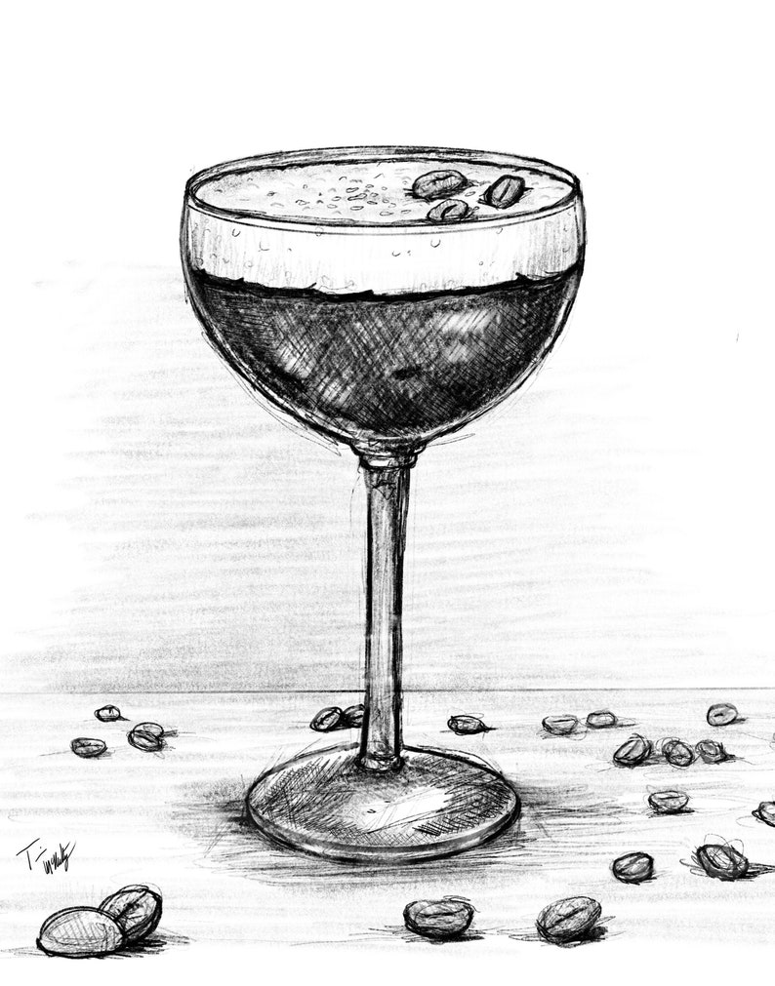

Red
Bellafontaine, Merlot – 14%, France Rich, vibrant and aromatic with soft plumy fruit flavours, complimented by soft silky tannins.
175ml £6 | 250ml £7.80 | Bottle £23
The Last Stand, Shiraz – 14%, Australia Delicate red fruit and herbal aromas open 3up the palate of mulberry and plum.
175ml £7 | 250ml £8.50 | Bottle £25
Nieto, Malbec Mendoza – 14.5%, Argentina Dark powerful red with a great concentrate of berry fruit, plum and figs with a smoky vanilla character.
175ml £8 | 250ml £9.50 | Bottle £28
Conviviale – Primitivo – Puglia 14%, Italy Rich, ripe flavours of plum, wild cherries and sweet spice, well balanced with ripe tannins.
175 ml £8.80 | 250ml £10.20 | Bottle £30
Les Hipsters Barbe – Bordeaux 14%, France Côtes du Bourg, Aromas of ripe dark fruit, broom flowers coconut & brioche. Savoury blackcurrants flavours. Juicy, intense, Suitable for vegans. Bottle £35
Sparkling
Lunetta Prosecco – Italy – 200ml bottle £8.50 Lunetta Prosecco Rose – Italy – 200ml bottle £8.50
Domenico De Bertoli Prosecco, Di Vaid – Italy
Light aromatic herbs on the nose, crusty bread, apples and peaches leads to a creamy, lemon-tanged palate and bright lively finish. Bottle - £28

Joseph Perrier Champagne, cuvée royal brut Fragrant from citrus fruit peel to apples and vineyard peaches precede the gentle finale of vanilla and cinnamon, soft persistent bubbles. Bottle - £56
Langham, corallian classic cuvée – Dorset, England The nose is intense with aromas of lemon, peach yoghurt and quince. The palate is rich with notes of nectarine, flint and salinity. There is citrus driven acidity with hints of peaches and cream. Bottle - £46
Langham, rose NV – Dorset, England Aromas of cherry bakewell, pink lady apple skin, yoghurt and wild strawberries. The palate reflects this this fresh red berry profile. Well balanced yet crunchy acidity. Bottle - £46

All wine by the glass is also available as a 125ml measure

